IRSwaption 평가 설명서

- Black Formula for Swaption
Swaption의 기초자산을 F(=forward swap rate)라고 하자.
$$F\left(0,T_{start},T_{end}\right)=\frac{P\left(0,T_{start}\right)-P\left(0,T_{end}\right)}{\sum_{i=1}^{N}{Δ\left(T_{i-1},T_{i}\right)P\left(0,T_{i}\right)}}$$
$$P(Payer Swaption)=N×Annuity×\left[f_{0}\left(T_{start}, T_{end}\right)N\left(d_{1}\right)-XN\left(d_{2}\right)\right]$$
$$N\left(y\right)=\frac{1}{\sqrt{2π}}\int_{-∞}^{y}{e^{-\frac{z^{2}}{2}}dz}$$
$$d_{1}=\frac{\left(\ln\left(\frac{f_{0}\left(T_{start},T_{end}\right)}{X}\right)+\frac{1}{2}v^{2}T\right)}{v\sqrt{T}} , d_{2}=d_{1}-v\sqrt{T}$$

- Bermudan Swaption
HW 1F FDM을 통해 계산
Discount Factor
$$P\left(t,T\right)=\hat{E}\left(e^{-\int_{t}^{T}{r\left(u\right)du}}\right)$$
The instantaneous spot rate, called “short rate”, is the interest rate r(t).
HW 1F Dynamics of Short Rate
$$dr\left(t\right)=\left[θ\left(t\right)-κ∙r\left(t\right)\right]dt+σ\left(t\right)dW=κ\left[\frac{θ\left(t\right)}{κ}-r\left(t\right)\right]dt+σ\left(t\right)dW$$
if $r\left(t\right)>\frac{θ\left(t\right)}{κ}$ Then Drift have (-) else (+)
$$r\left(t\right)=α\left(t\right)+x\left(t\right)$$
$$dα\left(t\right)=\left[θ\left(t\right)-κα\left(t\right)\right]dt$$
$$dx\left(t\right)=-κx\left(t\right)dt+σdW$$

HW 1F PDE
$$U_{t}=κxU_{x}-\frac{1}{2}σ^{2}U_{xx}+\left[α\left(t\right)+x\right]U$$
$$α\left(t\right)=-\frac{δP\left(0,t\right)}{δt}+\frac{σ^{2}}{2κ^{2}}{\left(1-e^{-κt}\right)}^{2}$$
Implicit Finite Difference Method
$$\frac{u_{i}^{k+1}-u_{i}^{k}}{h_{t}}=κx∙\frac{\left(u_{i+1}^{k}-u_{i-1}^{k}\right)}{2h_{x}}-\frac{1}{2}σ^{2}\frac{\left(u_{i+1}^{k}+u_{i-1}^{k}-2u_{i}^{k}\right)}{h_{x}^{2}}+\left[α\left(t_{k+1}\right)+x_{i}\right]u_{i}^{k+1}$$
$$u_{i}^{k+1}-u_{i}^{k}=h_{t}κx∙\frac{\left(u_{i+1}^{k}-u_{i-1}^{k}\right)}{2h_{x}}-\frac{h_{t}}{2}σ^{2}\frac{\left(u_{i+1}^{k}+u_{i-1}^{k}-2u_{i}^{k}\right)}{h_{x}^{2}}+h_{t}\left[α\left(t_{k+1}\right)+x_{i}\right]u_{i}^{k+1}$$

$$u_{i}^{k+1}\left(1-h_{t}\left[α\left(t_{k+1}\right)+x_{i}\right]\right)=\left[-\frac{h_{t}κx_{i}}{2h_{x}}-\frac{h_{t}σ^{2}}{2h_{x}^{2}}\right]u_{i-1}^{k}+\left[1+\frac{h_{t}σ^{2}}{h_{x}^{2}}\right]u_{i}^{k}+\left[\frac{h_{t}κx_{i}}{2h_{x}}-\frac{h_{t}σ^{2}}{2h_{x}^{2}}\right]u_{i+1}^{k}$$
$$u_{i}^{k+1}W_{i}=A_{i}u_{i-1}^{k}+Bu_{i}^{k}+C_{i}u_{i+1}^{k}$$

$$W_{i}=\left(1-h_{t}\left[α\left(t_{k+1}\right)+x_{i}\right]\right)$$
$$A_{i}=\left[-\frac{h_{t}κx_{i}}{2h_{x}}-\frac{h_{t}σ^{2}}{2h_{x}^{2}}\right]$$
$$B=\left[1+\frac{h_{t}σ^{2}}{h_{x}^{2}}\right]$$
$$C_{i}=\left[\frac{h_{t}κx_{i}}{2h_{x}}-\frac{h_{t}σ^{2}}{2h_{x}^{2}}\right]$$
Boundary Condition
$$u_{-1}=2u_{0}-u_{1}$$
$$u_{N+1}=2u_{N}-u_{N-1}$$
$$u_{0}^{k+1}W_{0}=A_{0}u_{-1}^{k}+Bu_{0}^{k}+C_{i}u_{1}^{k}=A_{0}(2u_{0}^{k}-u_{1}^{k})+Bu_{0}^{k}+C_{0}u_{1}^{k}$$
$$u_{0}^{k+1}W_{0}=u_{0}^{k}\left(2A_{0}+B\right)+u_{1}^{k}\left(C_{0}-A_{0}\right)$$
$$u_{N}^{k+1}W_{N}=A_{N}u_{N-1}^{k}+Bu_{N}^{k}+C_{i}u_{N+1}^{k}=A_{N}u_{N-1}^{k}+Bu_{N}^{k}+C_{N}\left(2u_{N}^{k}-u_{N-1}^{k}\right)$$
$$u_{N}^{k+1}W_{N}=u_{N-1}^{k}\left(A_{N}-C_{N}\right)+u_{N}^{k}\left(B+2C_{N}\right)$$
$$\left[\begin{matrix}\begin{matrix}2A_{0}+B & C_{0}-A_{0} & 0 \\ A_{1} & B & C_{1} \\ 0 & A_{2} & B\end{matrix} & \begin{matrix}0 & … & … \\ 0 & … & … \\ C_{2} & … & …\end{matrix} & \begin{matrix}0 & 0 & 0 \\ 0 & 0 & 0 \\ 0 & 0 & 0\end{matrix} \\ \begin{matrix} 0 & 0 & A_{3} \\ … & … & … \\ … & … & …\end{matrix} & \begin{matrix}B & … & … \\ … & … & … \\ … & … & …\end{matrix} & \begin{matrix}0 & 0 & 0 \\ 0 & 0 & 0 \\ 0 & 0 & 0\end{matrix} \\ \begin{matrix}… & … & … \\ … & … & … \\ … & … & …\end{matrix} & \begin{matrix}0 & 0 & A_{N-2} \\ 0 & 0 & 0 \\ 0 & 0 & 0\end{matrix} & \begin{matrix}B & C_{N-2} & 0 \\ A_{N-1} & B & C_{N-1} \\ 0 & A_{N}-C_{N} & B+2C_{N}\end{matrix}\end{matrix} \right]\left[\begin{matrix}u_{0}^{k} \\ u_{1}^{k} \\ \begin{matrix}u_{2}^{k} \\ u_{3}^{k} \\ \begin{matrix}… \\ … \\ \begin{matrix}u_{N-2}^{k} \\ u_{N-1}^{k} \\ u_{N}^{k}\end{matrix}\end{matrix}\end{matrix}\end{matrix}\right]=\left[\begin{matrix}W_{0}u_{0}^{k+1} \\ W_{1}u_{1}^{k+1} \\ \begin{matrix}W_{2}u_{2}^{k+1} \\ W_{3}u_{3}^{k+1} \\ \begin{matrix}… \\ … \\ \begin{matrix}{W_{N-2}u}_{N-2}^{k+1} \\ {W_{N-1}u}_{N-1}^{k+1} \\ W_{N}u_{N}^{k+1}\end{matrix}\end{matrix}\end{matrix}\end{matrix}\right]$$
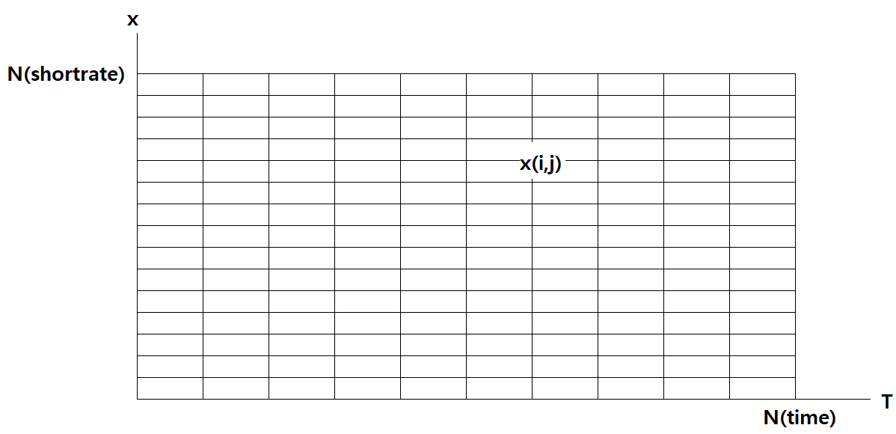
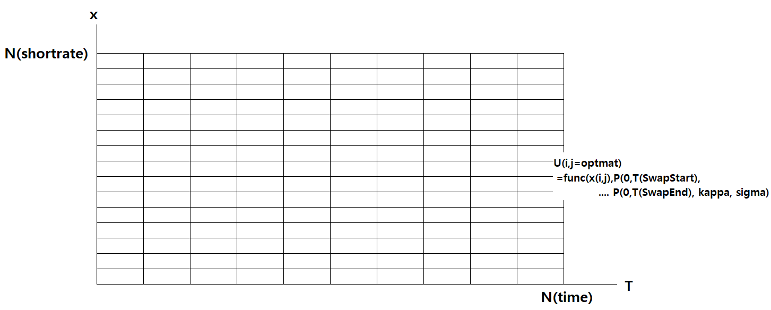
HW Forward Discount Factor
$$P\left(t,T\right)=\hat{E}\left(e^{-\int_{t}^{T}{r\left(u\right)du}}\right)=\hat{E}\left(e^{-\int_{t}^{T}{\left(x\left(u\right)+α\left(u\right)\right)du}}\right)$$
여기서 $\int_{t}^{T}{x\left(u\right)du}$는 평균 x(t)B(t,T), 분산 V(t,T)인 정규분포를 따른다.
$$B\left(t,T\right)=\frac{1-e^{-κ\left(T-t\right)}}{κ}$$
$$V\left(t,T\right)=\int_{t}^{T}{σ^{2}\left(u\right)B^{2}\left(u,T\right)du}≈\int_{t}^{T}{\frac{σ^{2}\left[1-2e^{-κ\left(T-u\right)}+e^{-2κ\left(T-u\right)}\right]}{κ^{2}}du}$$
$$=\frac{σ^{2}}{κ^{2}}\left(T-t+2\frac{e^{-κ\left(T-t\right)}-1}{κ}-\frac{e^{-2κ\left(T-t\right)}-1}{2κ}\right)$$

따라서 위험 중립 측도에서 $P\left(t,T\right)$는 정규분포의 적률생성함수(Moment Generate Function)에 따라 다음과 같다.
- $E\left(e^{tx}\right)=e^{μt+\frac{1}{2}{\left(σt\right)}^{2}}$ MGF of Normal Distribution 따라서,
$$P\left(t,T\right)=\hat{E}\left(e^{-\int_{t}^{T}{α\left(u\right)du}-x\left(t\right)B\left(t,T\right)+\frac{1}{2}V\left(t,T\right)}\right)$$

0시점 시장에서 관측된 만기 T인 Zero Bond $P^{M}\left(0,T\right)$가 다음을 만족한다.
$$P^{M}\left(0,T\right)=e^{-\int_{0}^{T}{α\left(u\right)du}+\frac{1}{2}V\left(0,T\right)}$$
$$e^{-\int_{0}^{T}{α\left(u\right)du}}=P^{M}\left(0,T\right)e^{-\frac{1}{2}V\left(0,T\right)}$$
따라서
$$e^{-\int_{t}^{T}{α\left(u\right)du}}=\frac{P^{M}\left(0,T\right)}{P^{M}(0,t)}e^{-\frac{1}{2}\left(V\left(0,T\right)-V\left(0,t\right)\right)}$$
$$P_{HW}^{x_{i}}\left(t,T\right)=\frac{P^{M}\left(0,T\right)}{P^{M}(0,t)}\exp\left(-x_{i}B\left(t,T\right)+\frac{1}{2}\left(V\left(t,T\right)-V\left(0,T\right)+V\left(0,t\right)\right)\right)$$
$$P_{HW}^{x_{i}}\left(t,T\right)=\frac{P^{M}\left(0,T\right)}{P^{M}(0,t)}\exp\left(-x_{i}×B\left(t,T\right)+QVTerm\left(t,T\right)\right)$$

HW Forward Swap Rate
$${FSR}_{HW}^{x_{i}}\left(t_{timenode},t_{forwardstart},T_{swapmat}\right)=\frac{P_{HW}^{x_{i}}\left(t_{timenode}, t_{forwardstart}\right)-P_{HW}^{x_{i}}\left(t_{timenode},T_{N}\right)}{\sum_{1}^{N}{\left[ΔT_{i}×P_{HW}^{x_{i}}\left(t_{timenode},T_{k}\right)\right]}}$$
$$* t_{forwardstart}=Forward Swap Start T$$
$$* T_{1}=First Swap Coupon T$$
$$* T_{N}=T_{swapmat}$$
HW Swaption Value
- Swaption Value on node $x_{i}$
$$U\left(t_{timenode}, x_{i}\right)$$
$$=max\left({FSR}_{HW}^{x_{i}}\left(t_{timenode},t_{forwardstart},T_{swapmat}\right)-Strike,0\right)\sum_{1}^{N}{\left[ΔT_{i}×P_{HW}^{x_{i}}\left(t_{timenode},T_{i}\right)\right]}$$

그리드 세팅 전에 미리 만들어야 할 변수들 3D Array
$$\left\{B\left(t,T_{k}\right) | k=0 to N\right\}→NOption×Time Greed개수만큼$$
$$\left\{QVTerm\left(t,T_{k}\right) | k=0 to N\right\}→NOption×Time Greed개수만큼$$
$$\left\{P\left(0,T_{k}\right)|k=0 to N\right\}→NOption×Time Greed개수만큼$$

C언어 함수
- $B\left(t,T\right)=\frac{1-e^{-κ\left(T-t\right)}}{κ}$
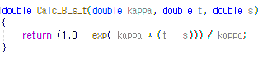
- $V\left(t,T\right)≈\frac{σ^{2}}{κ^{2}}\left(T-t+2\frac{e^{-κ\left(T-t\right)}-1}{κ}-\frac{e^{-2κ\left(T-t\right)}-1}{2κ}\right)$
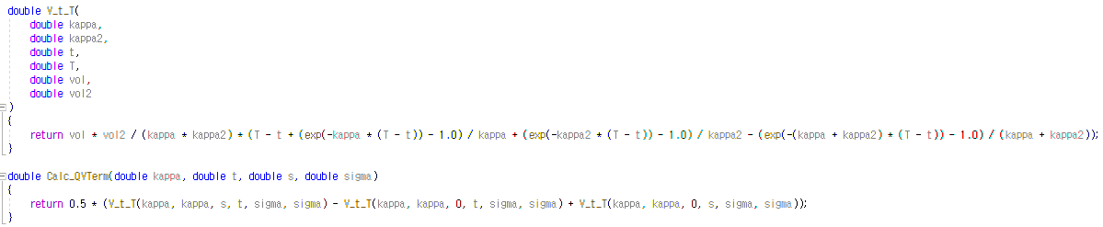
- $BSSwaption=N×Annuity×\left[f_{0}\left(T_{start}, T_{end}\right)N\left(d_{1}\right)-XN\left(d_{2}\right)\right]$
